

Registered with: | Member of:
 | 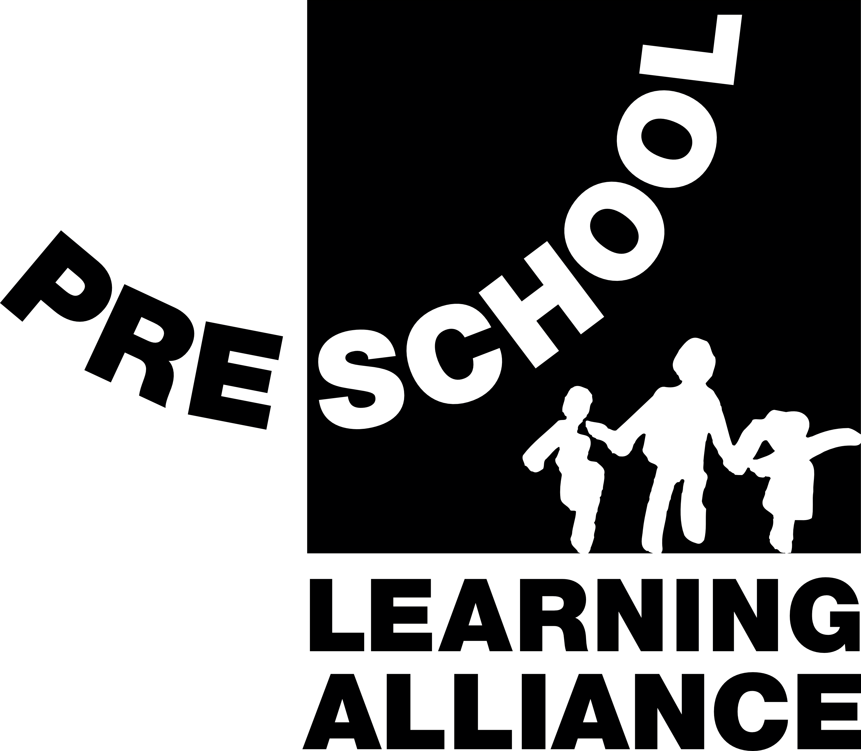



Welcome Pack

Broad Town Pre-School
and Forest School
2023

Nurturing little minds to create strong roots and spread their branches full of knowledge, caring and kindness

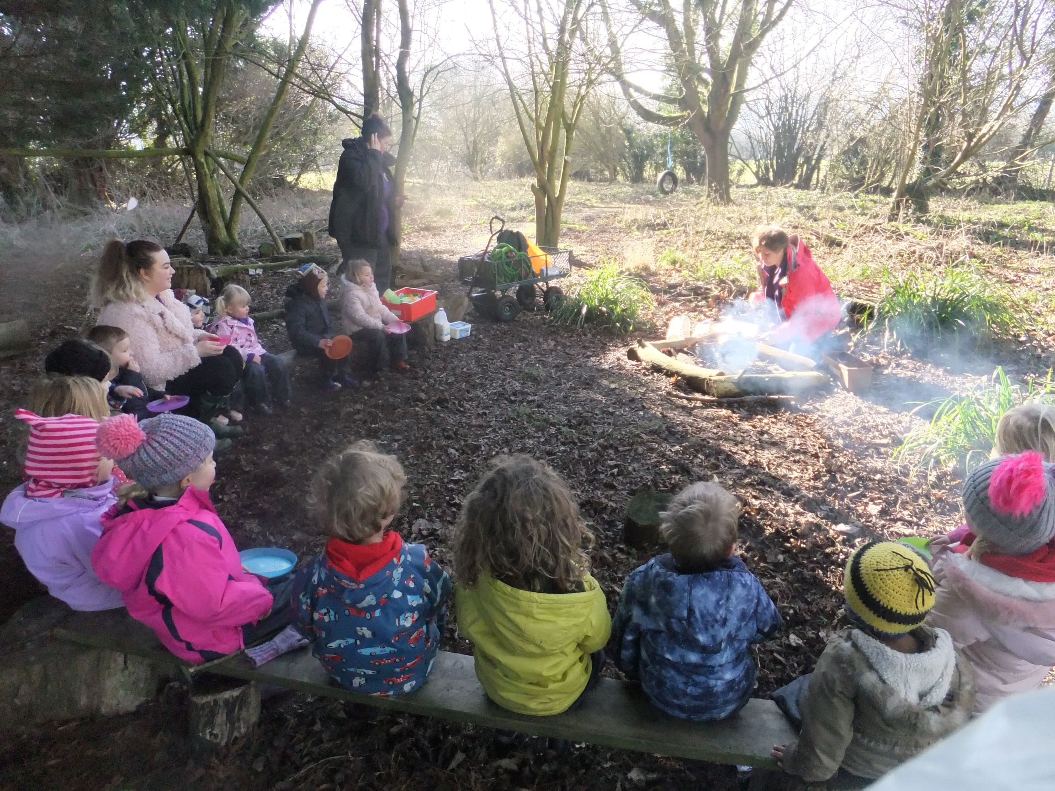

Registered Charity No 297152
Telephone 01793 731911
www.broadtownpreschool.co.uk email: admin@broadtownpreschool.co.uk

Contact Details

Broad Town Pre-School
Broad Town School
Broad Town
Wiltshire
SN4 7RE

www.broadtownpreschool.co.uk
email: admin@broadtownpreschool.co.uk

Pre-School Telephone Number - 01793 731911
Available during term time Mon–Fri 9.00am–3.00pm

Our Staff
Manager
Deputy Manager/acting manager Louise Coward
Pre-School Assistants Cherri Hewitt
Zoe Hunt
Harriet Connolly

Administrator Zoe Dyer

Our Committee
Chair John Kent – Telephone Number 07470 675208

Secretary tbc
Treasurer Judith Georgii

General Committee Members Dani Greenway
Katie Brooks
Molly Measures
Hannah Clarke

Welcome to Broad Town

Pre-School

We are a small, friendly Pre-School situated in the grounds of Broad Town School. We currently have an acting Deputy/ Manager, three Assistants, an Administrator, a Cleaner and are actively recruiting staff; all are supported by a committee of parents who help on a voluntary basis. The Pre-School is closely associated with Broad Town Primary School.

We are a registered charity (no 297152) and we are also active members of the Early Years Learning Alliance (EYLA). We have adopted our Constitution in accordance with the EYLA Constitution 1992 and adhere to this at all times.

We would like to ensure that your child is comfortable and happy and that their time spent at Pre-School is beneficial. For this reason, we have compiled this “Welcome Pack” to:

- Explain what happens during each session
- Let you know our general rules and policies¹ and how you can help
- Answer any questions you may have

¹ A copy of our full Policies and Procedures can be found in the lobby within the Pre-School or on our website, please take time to read through this.

We hope that your Welcome Pack will be of interest to new starters and also to those who already have a child at the Pre-School. Please keep it and refer to it during your time with us, the staff are of always available to answer any queries you may have.

Choosing a Pre-School for your child is a very important decision and we hope to be able to help you with the information contained in this pack. Our Pre-School was inspected by OFSTED in April 2018 and received a good report in all areas of its provision. The report stated:

“The dedicated and experienced team demonstrates a genuine interest and passion for its work. Staff join in with children as they play and support children to develop positive attitudes to learning. Partnerships with parents are strong. Parents speak highly of the pre-school team and feel included in their child's learning and development. Staff keep parents updated regularly about their child's progress.”

If you would like to see a copy of the report, please contact the Supervisor or the Chairperson, alternatively view this on line at www.ofsted.gov.uk, or via our website www.broadtownpreschool.co.uk. A copy of the report can also be found in the lobby

We are an equal opportunities* setting and we accept children and their families from all cultural, ethnic, religious and social groups and cater to all their individual needs. We are happy to accept children with special educational needs.

Forest School
We are a unique setting hosting a Forest School that is fully incorporated into Pre-School Life. Our staff are trained in promoting and using Forest School as a rich resource allowing all children to experience and explore the great outdoors.
What are the aims of our Pre-School?

We follow the Early Years Foundation Stage** (EYFS) Principles from birth to age five. In doing this we aim:

- To have happy, fulfilled and motivated children.
- To provide a stimulating environment for children to explore with their play and to learn from their experiences.
- For adults to support the child’s initiated play.

A Unique Child
- Child Development
- Inclusive Practice
- Keeping Safe and Secure
- Health and Well-being

Positive Relationships
- Respect for Each Other
- Parents as Partners
- Supporting Learning
- Key Person

Enabling Environments
- Observation, Assessment and Planning
- Making a Learning Journal
- Indoor and Outdoor Equipment
- Transition to School and the Community

Learning and Development
- Play and Exploration
- Personalised Learning and Making Decisions
- Understanding Each Other
- The 7 Areas of Learning

**What is the Early Years Foundation Stage?

This is how the Government and Early Years professionals describe the time in your child’s life between birth and age 5. This very important stage in your child’s development helps them get ready for school, as well as preparing them for their future learning and successes. From when your child is born up until the age of 5, their early years experience should be happy, active, exciting, fun and secure and support their development, care and learning needs.

Pre-Schools registered to deliver the EYFS must follow a legal document called the Early Years Foundation Stage Framework, which explains how and what your child will be learning to support their healthy development, through 7 areas of learning and development.

You can download a copy of the Parents’ Guide to the Early Years Foundation Stage Framework at http://www.foundationyears.org.uk/files/2015/01/EYFS_Parents_Guide-amended1.pdf

Introduction to the Sessions

Pre-School Sessions
Sessions are available Monday to Friday during term time as shown below:

Morning Session 9.00 am to 12.00 pm
Lunch Club 12.00 pm to 12.30 (to be taken in conjunction with morning/afternoon or all-day sessions
Afternoon Session 12.30 pm to 3.00 pm

Morning Session only 3 hours
Morning Session plus Lunch Club 3.5 hours
Lunch Club plus Afternoon Session 3.0 hours
Afternoon Session only 2.5 hours
All Day 6 hours

Fees are £6 per hour from April 2023

Rising 4’s sessions: every Wednesday afternoon we currently offer extra activities tailored to extend the knowledge of those children due to start school in the September of that year.

Early Years Free Entitlement Funding currently provides up to 15 hours per week for 38 weeks a year. Currently a child becomes eligible for this funding the term after which they turn three years old, the table below illustrates this:

Child's birthday | When you can claim
1 January to 31 March | The beginning of term on or after 1 April
1 April - 31 August | The beginning of term on or after 1 September
1 September - 31 December | The beginning of term on or after 1 January

Children with certain social and educational needs may qualify for funding before this, please ask a staff member if you need to find out more.

If both parents (or a lone parent) are working more than 16 hrs per week, you may be entitled to extended free funding totalling 30 hrs per week. To find out more please visit childcare choices website at the following address https://www.childcarechoices.gov.uk/ Any sessions not covered by Free Entitlement Funding, for example if your child is not yet eligible for Free Entitlement Funding, or attends for more than 15 hours a week and you do not receive the extended free funding, will be charged to you at the normal hourly rate.

Lunch Club
The lunch club is open to all children in addition to their morning and afternoon sessions. If you wish your child to attend lunch club in addition to their morning session, you would collect them from Pre-School at 12:30pm. If you wish your child to attend lunch club in addition to their afternoon session you would drop them off at Pre-school at 12.00pm.

Children bring their own packed lunch and are encouraged to eat it “in order” (i.e. sandwich, similar savoury food or fruit first and yoghurts or sweet foods last). A member of staff sits at each table to encourage this. We actively promote healthy eating during snack-time, offering milk or water and would like to ask parents to encourage their children to eat a varied and healthy lunch. Following are a few recommendations from the Department of Health for a balanced, healthy lunchbox:

First example | Second example | Third example | Fourth example
Ham sandwich | Cold, sliced pizza | French bread & | Sausage roll
Yoghurt | Packet of raisins | Cheese & cucumber | Cherry tomatoes
Apple | Fromage frais | Grapes | Yoghurt
Malt-loaf | Satsuma | Iced bun | Currant bun
Water | Water | Diluted fruit juice | Diluted fruit juice

Registration and Admissions
You can request a registration pack from our administrator by emailing admin@broadtownpreschool.co.uk To register your child please complete the registration form and return it to the Pre-School, via email or in person. You may register your child from the age of 12 months. Your child will be put on a waiting list and places will be offered using these priorities; start date and date of registration.

We would also ask you to sign and return the “Day Carers and Child Protection” form, included in this Welcome Pack, when you register your child. This contains detailed information about the Child Protection Legislation.

Once we have received your registration form and your preferred sessions/days have been confirmed by our Administrator, we will contact you within one month of your child’s start date to invite them to an introductory visit if required. If your visit prior to registration is close to your child’s start-date then this will be classed as an introductory session.
Once you have received confirmation of your child’s start date and sessions, any amendments requested may be subject to an administration charge.

Our policy states that children have to attend the minimum of two sessions per week.

Starting Pre-School Sessions – Please note that during the Coronavirus Pandemic we are not able to offer introductory visits, but have created an introduction booklet help ease the settling in period.
It is recommended that you attend an introductory visit for you and your child shortly before they start Pre-School. It is our policy that the parent/carer stays with the child for all of their first session introductory visit, so that the child becomes familiar with the staff and the classroom. Staff and your child’s designated key worker will work with you to find the best way to settle your child into the group.

Fees
Our fees are reviewed annually and are set by the Management Committee. We aim to keep our fees in line with other Pre-School Education Providers in the area.

Invoices for Pre-School fees are issued monthly to coincide with the first day in each month, by e-mail unless otherwise requested. You are expected to settle within 14 days if you fail to do so your child will lose their right to a place. Cheques should be made payable to Broad Town Pre School, or you may pay by internet banking. Please ensure any payment brought into Pre-School is in a sealed envelope clearly marked with your child’s name and what they are e.g. fees. Post-dated monthly cheques are acceptable by prior arrangement with the Treasurer. All sessions are usually booked termly in advance. There is no reduction in fees for absence due to sickness or holidays you may take during term time or no alternative days offered in lieu. Please note that during the Coronavirus Pandemic, if we remain open to all children, and you decide to keep your child at home there will also be no reduction in fees (please refer to our Admissions and Fees Policy)

What Happens At A Typical Session?
The following is a summary of what the children do. A different theme is chosen each half term, which is split into weekly/fortnightly topics. You will be emailed the themes and a copy of is always available on the notice board in the Pre-School and on our outside noticeboard that you will see as you walk down our path into Pre-School. It can also be found on our closed Facebook page, ‘Parents of Broad Town Pre-School’. The activities are organised to reflect the current topics and are planned around themes that cover the 7 areas of the curriculum. We have an interest table where children are encouraged to bring in something relating to the current weekly theme. Please note we do not permit items from home to be brought into pre-school during the Coronavirus Pandemic

Forest school sessions are currently suspended until Christmas. We will still be using the forest as part of our outdoor play area, but with limited activities. This is only temporary.
Forest school sessions are normally held on two mornings each week, and the Forest School session days rotate each term. All children who attend these sessions need to be dressed appropriately for the weather. Even in the summer please send them in long sleeves, long trousers and suitable footwear – this is to protect them from nettles, twigs etc. Forest school can however be used in other sessions. Waterproof leggings, coats and wellies are provided by Pre-School for use by children whenever needed.

Our afternoon sessions follow a similar format, although our Rising 4’s session on a Wednesday afternoon follow a slightly different format

*ALL TIMINGS ARE APPROXIMATE AS WE OFTEN RUN OVER*

09:00 Welcome and Free Play
Children hang their coats on named pegs in the entrance hall. Parents and children should remain in the area until the Pre-School door is opened.

Children sit on the carpet for registration and discussion about the theme. All activities are linked to a theme and cover all areas of the Foundation Stage Curriculum. Children self-register and are then free to play at the tables and to access other equipment inside and outside. Activities include paint, play dough, water, sand, magic dough and rice.

Snack Time with milk and water. Due to Covid-19 we have had to put into place safety measures to help reduce the risk of cross contamination, therefore we will no longer be providing snack. This will need to be supplied by yourselves. We ask that you please supply your child with 1 healthy low sugar snack per morning and afternoon session (if they are with us all day, you will need to provide 2 snacks) Please bring your child’s snack into Pre-school in a named container so we can ensure that every child gets the correct snack.
We have gone from having a group snack time altogether to introducing a ‘rolling café’ snack time where children can chose at what point during the morning and afternoon free flow they have their snack. This encourages independence and is less disruptive to your child’s play and learning. Children are offered and encouraged to have snack, but sometimes may chose not to. Rolling snack also gives children a choice, builds confidence, self-esteem and self-awareness.

11:00 Storytime

11:15 Physical Play
This takes place outside with a selection of equipment including bikes, bats, balls, hoops, and pushchairs. An outside play area with sandpit, water play and various other activities are also used. We also use the school’s grounds and equipment, as well our Forest School, and dance, drama and movement sessions are held in the Pre-School building.

11:45 Singing/Music/Story

12:00 Home time for children not staying for lunch club.

Lunch
Please note that a full lunchbox with drink should be provided. Please provide a cool/ice pack as we are not able to refrigerate lunchboxes.

12:30 Home Time for children who are not staying for an afternoon session/start of the afternoon session.

The children are encouraged to use the toilet facilities at any time in the session and are regularly asked whether they need to go and helped if needed.

Important Information

Rest and Relaxation
It is the Pre-School's policy that if a child is very tired, they are encouraged to have a quiet time and perhaps a short nap. There will be opportunities for all children to have a relaxing time on soft cushions within the book corner area, particularly after lunch and whenever a child needs a rest. Please feel free to discuss individual children's sleep patterns with the Supervisor, e.g. if a child is not sleeping at night and is very tired a parent may be happy with a longer sleep.

Potty Training
For younger children there are safe nappy changing facilities at the Pre-School. Please provide a small supply of nappies and wipes along with any lotions you may use and keep these in your child’s bag on their coat hook. Many 2-3-year-old children attending Pre-School are likely to be ready to start using the potty. Please let us know when you start potty training at home and we will work with you to ensure there is consistency of approach at home and in Pre-School. There are bound to be a few “little accidents”, so it is useful to have a change of clothes, to put onto their hook. The Pre-School also has spare clothing, just in case.

What to Wear,
We do have a uniform (T-Shirt, Polo shirt and jumper) which you can purchase but it is by no means compulsory
In order to feel free to explore and experiment with all kinds of materials, including messy ones, it is best to send children dressed in clothes which are easily washable and not too new. We support children to practise the skills needed to help them on their way to independence. Simple clothing, which they can take on and off and put on themselves, will give them the success of being able to go to the toilet and to undress for P.E. sessions with minimal adult support. Please label your child’s clothing to avoid any misunderstandings and help us to re-unite lost property with the owner. Waterproof jackets, trousers and wellies are provided daily during each session. Lost property is kept in a box in the lobby. All lost property will be donated to charity at the end of term if not claimed.

Collecting Your Child
PLEASE BE AWARE FOR SAFEGUARDING REASONS NO-ONE UNDER THE AGE OF 16 IS ALLOWED TO COLLECT A CHILD FROM PRE-SCHOOL UNACCOMPANIED. If you are not collecting your child, please ensure that the Staff is made aware of this and that they have the details of the person who will be collecting your child. He or she will not be released into the care of anyone except you unless instructions have been made to the contrary. It is essential that your Registration Form includes details of anyone to whom custody should not be given. If, for any reason you are unavoidably detained, please ring the Staff on the telephone number listed in this document. It is important that your child is collected promptly since, if the staff are unable to contact either the parent or emergency contacts then after 30 minutes the police will be contacted, followed by the Child Protection team at Social Services.

The staff cannot release your child to an unauthorised person, even if the collection is late, unless an authorised person telephones to state that because of an emergency a different person will be collecting. The authorised person should give the name and address and a physical description of the unauthorised person and the Staff will check this description before permitting your child to leave. The person collecting must also provide the appropriate password given on your registration form.

Communication
Our preferred method of communication is by email. In the event of an emergency, or if your child becomes sick during a session, we will call you on the 1st emergency number that you provided when registering (you are asked to provide 1st, 2nd and 3rd emergency contact numbers)
In the lobby area there is a Parent Notice Board where you will find our policies and procedures, latest OFSTED Report and other documents. You will also find information regarding future fund-raising events and social gatherings, together with the most recent newsletter. We also have a closed Facebook page ‘Parents of Broad Town Pre-School’ where we share information and updates with parents.
If there are any other documents you wish to see, please feel free to ask the Staff or Chairperson.

Accidents & Emergencies*
All our staff members have undertaken First Aid training. You will be asked to sign a slip giving permission for your child to receive emergency medical treatment or first aid as appropriate. All accidents, however minor, have to be recorded in the accident book. You will be asked to examine the site of the injury and sign the book in case of complications. Accidents of a severe nature have to be reported to the Social Services Department within three days.

Monitoring your child’s progress
Each child has one special member of staff to relate to, a designated Keyworker which eases the settling in process. This key worker system gives each member of staff particular responsibility to tailor the group’s curriculum to the unique needs of each child, enabling them to reach his/her full potential. The key person maintains links with the child’s family, records ongoing assessments and development of the children in their group.

This information is confidential and is only available to that child’s parents. If you wish, you may view your child’s learning journal at any time. A parents’ evening is organised twice a year to enable a detailed and confidential discussion to take place with the key worker on your child’s progress, however please feel free at any time to contact your key person to talk about your child.

Rewarding Positive Behaviour
Members of staff in the pre-school will praise and endorse desirable behaviour such as kindness and willingness to share and help others. We use verbal praise, stickers and stars to reward a child and encourage positive behaviour. Please see our Behaviour Management Policy for more details

Birthdays & Special Celebrations – Please note we do not permit items from home to be brought into pre-school during the Coronavirus Pandemic
To make each child’s birthday special, the staff will give them a small present from the Pre-School. Parents can bring in a birthday cake or some small cakes to help celebrate the day if they wish. (To protect children with allergies please can we ask that cakes containing nuts are not brought in and if cakes are homemade, we require a list of ingredients). We take photographs to place in each child’s learning journal.

Pre-School children may also receive gifts related to specific festivals and special occasions, such as Easter or Christmas, as part of making these occasions memorable. For example, a chocolate lolly given to all those children attending the Pre-School Easter Egg Hunt. These gifts will always be of an appropriate nature to the occasion being celebrated and will be given in line with Pre-School’s Safeguarding and Equality policies and procedures.

Health* - If your child or anyone in your household has symptoms of Coronavirus, please stay at home and book a test by visiting www.gov.uk/coronavirus you will also be able to find the latest isolation period guidance.

If your child is not well, please see our guidance below. If you are not sure please ring us. Please keep the Manager informed of any medication your child may require (e.g. asthma inhaler). We can only administer medicine which has been prescribed by a doctor. Written instructions must be given, and the medicine must be in its original container.

Five Golden Rules

- Children must not be left if they are vomiting or have diarrhoea. They must be kept away for 48 hours after vomiting or diarrhoea has ceased.
- Children known to be unwell and with a temperature should not attend Pre-School. Children becoming ill during the day should be collected by a parent or carer.
- Children with pink eye e.g. conjunctivitis should not attend Pre-School until medical treatment has been provided and used for 24 hours.
- Children with oozing or weeping sores e.g. impetigo that cannot be covered with a dressing, should not attend Pre-School. Children with chickenpox must be kept home until all the scabs are dry (Usually 5 days from onset of rash or other symptoms).
- Colds are infectious. A mild cold will cause little distress. However, a child with a heavy cold or flu, who has a temperature should be nursed at home.

Taking precautions means protecting other children from unpleasant illness that could have been avoided. Parents can support childcare workers by following these five golden rules.

Other Considerations:
Headlice:
Please let us know if your child has headlice. Check your child’s hair regularly, use shampoo and conditioner and run a nit comb through damp hair. Continual vigilance will reduce the chance of reoccurrence.
Threadworms:
These are easily treated. Once treatment has begun the child can return to Pre-School.
Infectious Diseases:
Parents should tell the Pre-School if their child has been diagnosed with an infectious disease e.g. measles, chickenpox, rubella etc.
We all agree that children are better nursed at home within familiar surroundings. We recognise that it is difficult for working parents to take time off to look after their sick children, but equally child care providers have a duty to protect other children in their care from infection. The following guidelines aim to help parents make an informed decision as to whether your child should be kept away from Pre-School*: This information is also available on the noticeboard in the lobby area

Cause for Complaint?*
We hope that your child will have a happy and fulfilling time with us at Broad Town Pre-School. If you have any problems at all, however minor, please approach either the Supervisor or, if you prefer, a Committee member. A full list of Committee members and a contact telephone number for our Chairperson is at the beginning of this pack, and on the notice board at the Pre-school. If you would prefer to put your complaint in writing, please address it to the Manager and post it in the letter box inside pre-school.

Management and Staffing
Broad Town Pre-School is run by a Committee, whose members and officers are elected by parents. This committee ensures that major decision-making is in the hands of parents who use the group. It is responsible for reviewing both policy and practice and for the employment and appraisal of staff. The Committee relays any information to parents via our newsletter.

Our Annual General Meeting, at which the committee for the following year is elected, is held annually at the end of the summer term. Parents are always more than welcome to join the committee. You can register your interest in joining and helping out by speaking to the Manager any of the committee members. Please don’t be shy, we always welcome any help. Our staff and committee members have all been Police checked and hold a clean Criminal Records Bureau Disclosure as required by OFSTED.

Any other way I can help? YES PLEASE!
We are a voluntary organisation and a registered charity. We welcome new parents and new ideas. Your fees are used to cover the salaries and running costs of the Pre-School. We rely heavily on fund raising in order to replace and renew toys and equipment and we appreciate extra help. Please join our committee: This enables you to become more involved in the group as well as getting to know other parents and carers. Any parent that is able to offer us a special skill or learning opportunity within one of our curriculum topics is always very welcome. Please speak to the Supervisor or Chair Person. We keep a register of volunteers (please complete the form at the end of this welcome pack).

