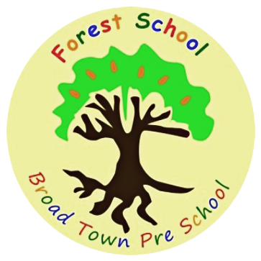
Broad Town Preschool is seeking a qualified Early Years practitioner to join our team!
We are passionate about the outdoors and promoting the forest school ethos. Our small setting is set in a quiet Wiltshire village next to open fields and benefits from a lovely woodland area used for forest school sessions.
We are looking for a lively, fun practitioner qualified at level 2 or 3 to join our friendly setting at Broad Town Pre-school. We provide care & education for children aged 2 to 5 years old. Our purpose built premises is well equipped, with free-flow outdoor play. We are open Monday to Friday in term time for a maximum of 25 children offering an environment that enables child-initiated play in order to capture teachable moments.
We are committed to safeguarding and this post is subject to a DBS check and is exempt from the 1974 Rehabilitation of Offenders Act.
Essential criteria:
1. Level 2 or above qualification in Early Years Care and Education (or equivalent)
2. Proficiency in oral and written communication
3. Willingness to learn & undertake appropriate training
5. Previous experience of working with young children

Main Duties:
1. To work as a team member with reporting directly to the manager/deputy manager, as required;
2. To assist senior staff members with the planning of the curriculum and activities;
3. To help to set up the classroom for the daily programme and to tidy away at the end of the session;
4. To act as a key person to a small group of children, liaising closely with parents/carers, and ensuring each child’s needs are recognised and met;
5. To advise the Pre-school Manager of any concerns e.g. over children, parents or the safety of equipment, preserving confidentiality as necessary;
6. To teach children, offering an appropriate level of support and stimulation;
7. To attend training courses and meetings as required;
8. To keep completely confidential any information regarding the children, their families, other staff, or the business arrangements of the Pre-school which is learned as part of the job.

This post is exempt from the Rehabilitation of Offenders Act 1974. Applicants must be prepared to disclose any convictions they may have and any orders that have been made against them.
Job Types: Part-time, Permanent
Salary: £10.72 - 11.50/hour, depending on qualifications and experience
Expected start date: ASAP
Please submit an up to date CV and cover letter to one of the email addresses below or if you require more information regarding this position, please contact: Judith on treasurer@broadtownpreschool.co.uk or Zoe on admin@broadtownpreschool.co.uk

