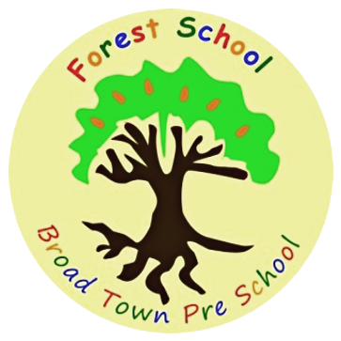
Broad Town preschool is seeking a preschool manager to lead our team!
Would you like the opportunity to manage an Ofsted rated ‘Good’ pre-school?
Are you looking to make a real difference to children’s lives in the local community?
Would you enjoy the opportunity to work in the setting for 3-4 days and time out (1-2 days) of the setting to fulfill your managerial responsibilities?
Are you confident in supporting a team, leading meetings, and work with a range of different professionals?
Our small setting is set in a quiet Wiltshire village next to open fields and benefits from a lovely woodland area used for forest school sessions. We are passionate about the outdoors and promoting the forest school ethos.
Applicants must:
- Have completed Level 3 in early years
- At least two years’ proven experience of working in an early year’s care and education setting or at least two years’ other suitable management experience.
- Have a sound knowledge of child-development and the EYFS
- Have the desire and ability to develop excellent partnerships with parents about their children’s learning
- Have a secure understanding of safeguarding policy and procedures
- Have excellent diplomacy and communication skills in order to present information confidently
- Be positive, dynamic, energetic and robust
- Confident leading a team
Please apply with an up to date CV and a short cover letter to the following email:
admin@broadtownpreschool.co.uk
Starting date: ASAP
Job Types: Part-time/Full-time, Permanent
The role:
£14.80 - £15 per hour depending on qualifications and experience.
~ 32 hours per week, term time only (39 weeks a year in total)
This post is exempt from the Rehabilitation of Offenders Act (1974) and does require an enhanced Disclosure and Barring Service Check. Applicants must be prepared to disclose any convictions they may have and any orders which have been made against them.

