FOREST SCHOOL

15.1 General Forest School Policy

Aims
By producing and adopting this policy for Forest School we aim to give all children and practitioners a collective insight into the ethos of Forest School. This is in addition to Broad Town Pre-School Policies and Procedures, listed at the end of this document

Forest School builds on a child’s innate motivation and positive attitude to learning, offering them the opportunities to take risks, make choices and initiate learning for themselves. The Forest School learning environment provides opportunities for children to develop self-esteem, self-confidence, to form positive relationships with others, to develop a growing awareness of their emotional needs and the needs of others, to learn to co-operate and work with their peers and adults and to develop strategies in order to take risks within the boundaries of safety.

Forest School is about exploring and experiencing the natural world through practical activities. The children go out in all weathers, all year round, exploring and learning from seasons and environment changes.

Appropriate clothing will be worn and during high winds it will be considered unsafe to go into the woods (branches could fall on their heads). The children’s interest along with the varied natural resources in our woodland are used to stimulate creative thinking, problem solving and skill development, all through play.

Environmental Considerations and Conservation
One of the principles of Forest School is to promote environmental awareness and encourage sustainability. The children are taught about respect and responsibility for the world around them. Both children and adults are encouraged to respect their environment and to be aware of conservation issues of the woodland around them.

The aim is to promote respect for wildlife which will be achieved through detailed session plans, evaluation and careful reference to our woodland management plan and ecological impact assessment.

If appropriate, reclaimed, recycled and sustainable resources will be used to maintain and develop our forest school site.

Health and Safety Considerations
Please refer to the Pre-School’s Health & Hygiene Policy and Safety Policy.

The health and safety of the adults and children is paramount at all times throughout any activity and session. Safe practice is reinforced through regular reminders eg always return to the fire circle when the whistle is blown, be careful of nettles, tree roots and branches at head height.

The Forest School programme provides children with opportunities to develop independence and to take responsibility for their own learning allowing them to develop early risk assessment strategies and understand their actions have consequences.

Roles and Responsibilities
The Forest School Leader will hold the full recognised Forest School Qualification, DBS and paediatric First Aid Qualification, and will have overall responsibility for:

- Planning of sessions
- Safety and risk assessment including pre-checks (site and kit)
- Medical details & parental permission
- Correct staffing ratio
- Administration of first aid
- Appropriate clothing
- Supervision of hand tool use and all tool kit security
- Understanding of any SEN within the group/individuals’ and pastoral needs of the group
- Emergency procedures
- Evaluations

Other staff and volunteers will:

- Have certain delegated duties
- Model good practice
- Support and talk to children, extending their learning as appropriate

Insurance
Insurance of activities is included under the Pre-School’s insurance policy.

Equal Opportunities
Please refer to the Pre-School’s Equal Opportunities for All Policy.
All people involved in Forest School sessions will be treated with respect and equality. Our priority is to ensure that children and adults have access to a safe and secure environment, in terms of emotional well-being and safety. We would like everyone involved to believe that any contributions they make to our sessions will be listened to and appreciated.

Evaluation Procedure
The Forest School Leader will ensure that the Forest School Programme is progressive, and undertakes to reflect and evaluate each session after completion. The Forest School Leader will reflect and act upon evaluations from children and other staff members to inform future planning.

15.2 Forest School Lost Child Policy

The following policy is for action in the event of a Lost or Missing child. (Please also refer to Broad Town Pre-School Procedure 9.3 “Procedure to be followed if a child is lost”)
Should a child become lost then this is “a serious incident” and should be treated as such. Therefore the following action should be taken:
- Alert the member of staff in charge who will make enquiries of relevant members of staff as to when the child was last seen and where.
- Remember the safety of the other children, with regard to supervision and security.
- Ensuring that the remaining children are sufficiently supervised and secure, one or preferably two members of staff should search the building, garden and immediate vicinity of forest school.
- Designated Safeguarding Lead in setting to inform Ofsted of serious incident occurring (lost child).
- Designated Safeguarding Lead in setting to inform Public Liability Insurer of serious incident occurring (lost child).
- Designated Safeguarding Lead in setting to inform Designated Officer for Allegations (formerly known as LADO) of serious incident occurring (lost child).
- If the child cannot be found within fifteen minutes then the parents and Police must be informed.
- Continue to search, opening up the area, keeping in touch with mobile phone if available
- Designated Safeguarding Lead in setting to investigate how serious incident occurred, and take steps to minimize future occurrence.

In the event of such a loss the Designated Safeguarding Lead in setting will investigate the circumstances under which the serious incident occurred, in order to establish whether a failure to follow the procedures had occurred and to establish what action needs to be taken to minimize future occurrence.

15.3 Forest School Fire Safety Policy

Campfires and the use of Kelly Kettles are an important part of Forest School and are used in many sessions. Broad Town Pre-School aims to ensure that all children and adults participating in Forest School sessions with fires and/or Kelly Kettles will do so safely and with as little risk to their health as possible.

Location
- Only previously agreed areas will be used for camp fires
- Campfire areas are enclosed by logs or large stones to prevent the spread of fire
- Kelly Kettles are used only on flat ground and any woodchip or leaf litter must be brushed away before use.

Positioning of Children and Adults
- Fire areas are surrounded by seating logs at least 1.5 metres from the fire pit.
- When the campfire is in use, children are not permitted to access the area without permission.
- When in forest school, children must walk around the outside of the seating logs and wait for permission to step over. Once permission has been given, they must sit, ensuring legs are drawn into the log and not outstretched.
- Once seated around the campfire, the children must remain seated until directed by an adult to move.
- Children will be taught how to change seats by standing, stepping over the log and then walking around the outside of the seating area. They must never cross the inner area.
- Long sleeves and trousers must always be worn.
- Children are not permitted to throw anything onto the fire.
- If there is a clear wind direction, seating in the line of the smoke is to be avoided.

Type of Fire
Training is provided for leaders regarding the best fire lay to use for a session:
- Waffle fires are used to provide a large amount of heat and light and are fast burning.

Safety and Responsibility
- Only adults are permitted to light fires. This will usually be the Forest School Leader.
- No flammable liquids are to be used to light or accelerate fires.
- No plastics are to be burnt.

Extinguishing
- All fires must be extinguished at the end of a session.
- Water should always be to hand during campfire sessions.
- Whenever possible, all fuels should be burnt off to ash.
- Forest School Leaders should ensure that any large remains of wood, especially when using a long log fire, are separated from one another.
- At the end of the session, the fire must be doused down with water and stirred until all smoke and steam has ceased.
- Large build-ups of potash, from several fires, need to be dispersed. This must only be done when it has totally cooled, preferably the following day. It should be finely scattered throughout the woodland to enable natural decomposition.

Kelly Kettles
- Only adults are to light the fire in the fire pan (see Safety Responsibilities section).
- The Kelly Kettle must be placed on flat, clear ground.
- Children must be seated at least 1.5 metres away from the Kelly Kettle.
- Children can feed the fire with one-to-one supervision, but they must have been shown how to do it safely. (Stick held at the end and dropped in from the side; hand should never be placed over the top of the kettle.
- Fuel should burn itself out, but if it doesn’t it must be extinguished with water (see above).
- Kelly Kettles should never be boiled with the cork in.

15.4 Forest School Hand Tool Safety Policy

Using small hand tools is an important part of Forest School as it enables children to develop new practical skills that help them develop self-confidence.
Hand tools are to be maintained in good order by the Forest School Leader(s) and will be inspected before each session to ensure safety.
Children and adults will be taught how to handle tools properly and to treat them with respect. Whilst using the hand tools the staff-to-child ratio is increased. This will be achieved by following these guidelines:
- Staff-to-child ratio: 1:2
- Tools will be kept in the Forest School Tool Bag and removed only by Forest School Staff or volunteers.
- Pen knives must be opened and closed by Forest School Staff or volunteers.

- Running with tools is prohibited.
- Pointing with tools is prohibited.
- Children will lose permission to use tools if the guidelines are not followed.
- Bill hooks should not be swung or used with gloved hands.
- Bow saws must have a blade guard in place when not in use. Blade guards to be removed and replaced only by Forest School Staff.
- Wood being sawn must be supported on a saw horse or a natural sawing break – hands must be kept clear of blade.
- When using pen knives to whittle, this must be done at the side of and downwards of the body.
- All tools must be counted back into the tool bag at the end of the session.
- Volunteer helpers must receive basic training on the use of individual hand tools before being permitted to use them with children.

15.5 Forest School Eating Policy
Broad Town Pre-School recognises that raising awareness of the woodland environment increases children’s interest in edible berries and fruits which may be found outside.
However, there is no safe way of ensuring that children will always eat correct berries and/or fruit, or that appropriate berries and/or fruit will be clean.
There is also the possibility that by promoting the correct ingestion of berries and/or fruit in Forest School sessions may lead to the incorrect identification by children when out of school.
With these considerations in mind, Broad Town Pre-School adopts the following policy on the eating of food during Forest School sessions:
- Forest School sessions on site (ie those lasting a maximum of 1.5 hours) will adopt a nil-by-mouth (no pick, no lick) policy with the following exceptions:

- Hot drinks made in storm kettles for the group from commercially available products such as hot chocolate.
- Drinks and foods which link directly to the topic, such as elder cordial, which will only be sourced from commercially available products.
In such cases, the Forest School Leader will be responsible for checking that no member of the group has any listed allergy to any of the products; if they have, the Forest School Leader will use their discretion as to whether a substitute product or different activity will be most appropriate.
- Longer Forest School sessions will adopt a nil-by-mouth policy with the following additional exception:

- Break time snacks and packed lunches brought by the children may be consumed by the children whilst on Forest School activities, provided careful monitoring by all staff ensures no berries and/or fruit from the forest is consumed.

- Children will be taught, at an age appropriate time, reasons why berries and/or fruit from the woodland may not be eaten during Forest School sessions. They will be reassured that fruit from the woodland can be safe to eat, but can equally be dangerous and that adult (ie parent) supervision is very important in ensuring only the correct berries are eaten.

The Forest School Leader will carry out a risk assessment at the beginning of each term which will take into account seasonal change. In addition a risk assessment will be undertaken before each Forest School session.

The Forest School site is at Broad Town Pre-School/Broad Town School and is located at the bottom of the school playing field.
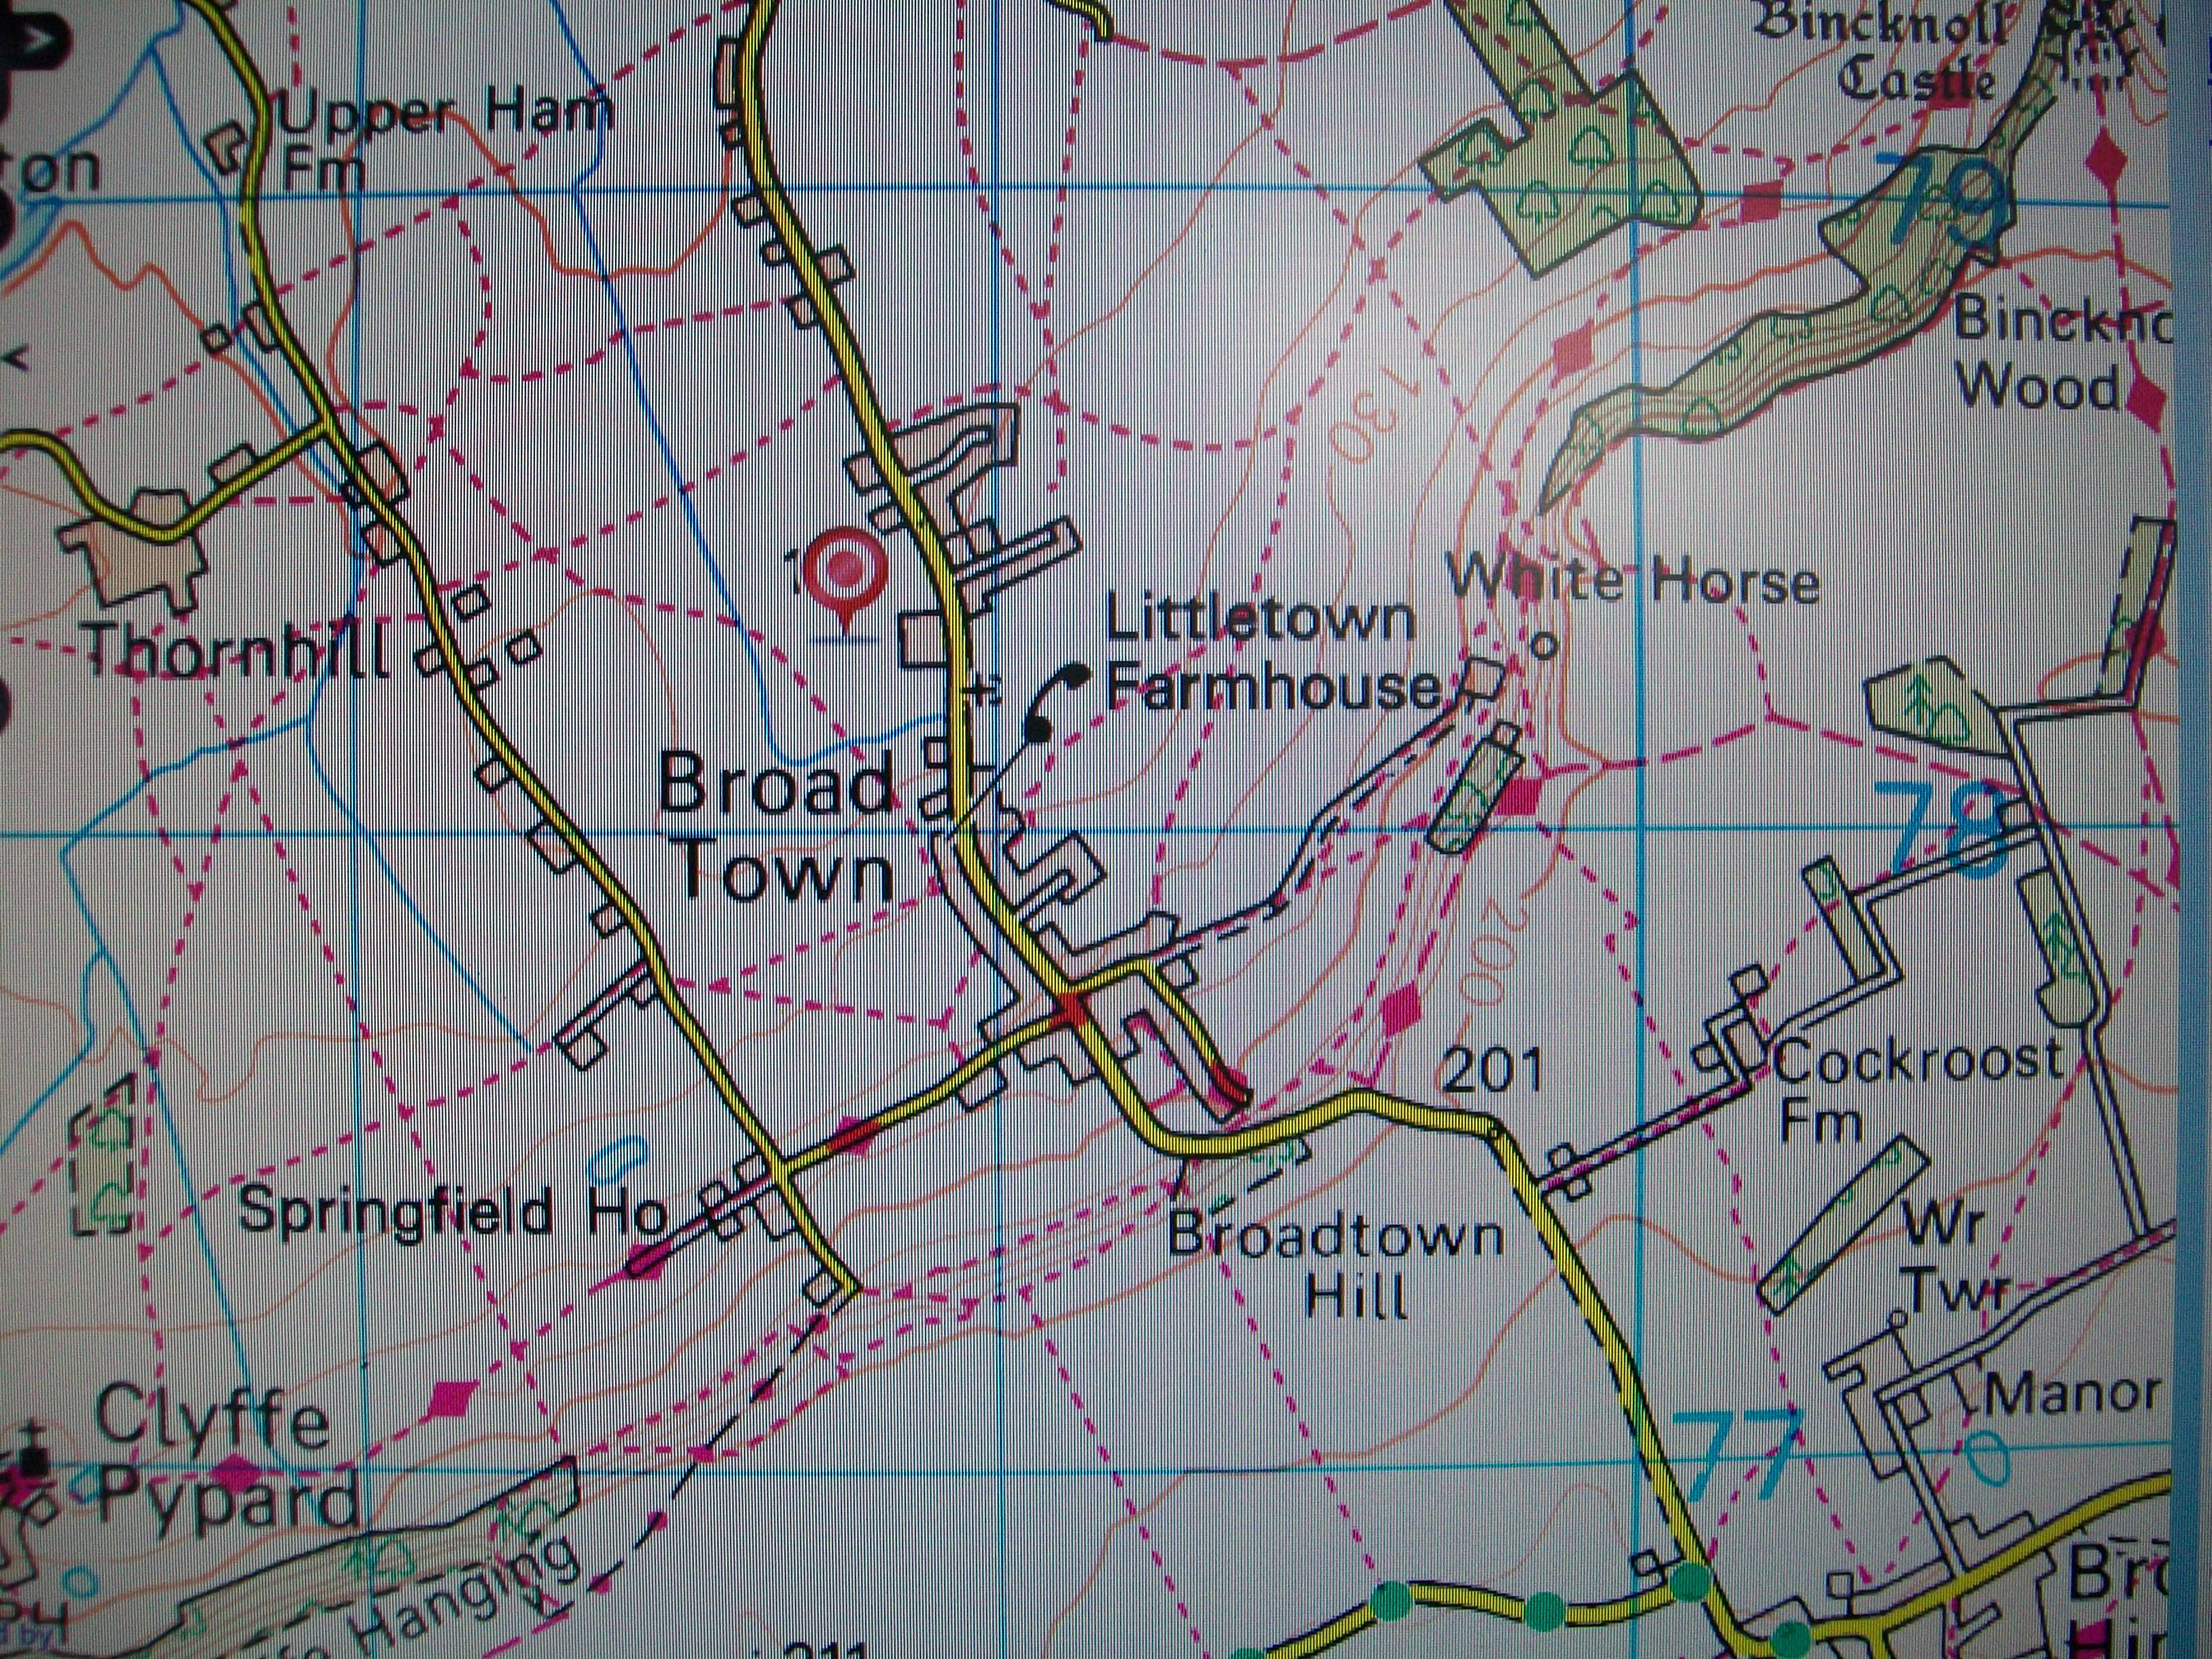
Map detail and grid reference below:

Access: A | SU 088,783
Off the B4044
Helicopter: H | SU 088,782
Site: S | SU 087,782

- Everyone involved in Forest School is fully briefed on the Health and Safety risk assessment of the site and activities. Staff and volunteers should be made aware of Health and Safety, Child Protection, Equal Opportunities and First Aid Policies, and ensure that they adhere to the guidance contained in them.
- All staff at Broad Town Pre-School undertake Child Protection training. Any concerns are reported to the Pre-School Manager, Emily Boniface and DSL- Louise Coward to ensure the Child Protection Policy is followed.
- All staff have an enhanced level DBS check.
- Suitable clothing and appropriate footwear must be worn at all time (NB sunscreen and hats to be worn in hot weather)
- We adhere to the Pre-School Confidentiality Policy at all times.
- Fire is always supervised by the Forest School Leader when lit and is never left unattended. Safe fire practice is always adhered to. There will always be a bucket with minimum 5 litres of water and a damp cloth next to the fire. Children will be taught and reminded of the fire circle rules:

Stand behind or on the outside of circle of logs
Step over and sit down on a log
Stand up, turn around and step over a log
Children are not allowed to cross the circle

- Forest School Leaders and other adults are aware of the following when cooking and eating at Forest School:

Everyone should wash/gel their hands before handling food and drink.
All foods are stored in airtight containers.
Only clean equipment is used.
Everyone is aware of any special dietary needs, food allergies, and any medication pupils may be taking.
Care plans are in the Forest School Leader’s bag.
Food will be cooked correctly.
All equipment and waste is cleared away.

- Tools inventory and storage of tools are checked after each session.
Children will have 1:1 adult supervision if using tools that are age-appropriate.

- Rules are set out clearly at the beginning of each session. Persistently bad behaviour will result in withdrawal from task.

Dealing with strangers, members of the public and loose dogs
Children will be informed to never approach anyone or animal in the forest area.
Look for owner and ask to keep dog on lead.
In an emergency, do not approach dog from the front, do not have eye contact with dog, stand still and look upwards.

Emergency Kit Bag Contents:
Full First Aid Kit
Mobile phone
Risk Assessment
Non-antiseptic wet wipes
Fire blanket & cling film
Pen & accident book
Pen knife
Bin bags
Scissors

Extra Equipment and Tools:
Session Plan with specific activity and resources
Camera
Fire kit including safety matches
String
Rope

Emergency Procedures:
Forest School Site on school premises.
In case of injury to adults or children:
- Forest School Leader to administer first aid to casualty
- Ensure the safety of the remainder of the group
- Alert emergency services if necessary
- Inform Head Teacher if incident requires further treatment
- Information to parents
- Seek further aid if required
- Refer to emergency contacts below
- Emergency Phone Numbers
Please refer to Forest School First Aid Policy and emergency procedure:

- If an accident involves a pupil, member of staff or a visitor that requires help in addition to First Aid ie Fire, Ambulance, Police, the Local Authority (LA) must be informed of the circumstances as soon as possible.
- In the event of serious injury, the Health and Safety Executive (HSE) must be informed. This notification is a legal requirement.
- The Accident Report form requires a written statement with reference to the sequence of events, actions taken and responses, and times of these actions. Names of witnesses should be recorded.
- A copy of the Accident Report form will be filed in Pre-School.
- The process outlines above is of vital importance to the enquiry that will surely follow a serious accident, and will be critical to any action for damages or compensation.

